## Prediction of Biochar production from food waste pyrolysis using machine learning techniques

### A PROJECT

***Submitted in partial fulfilment of the requirement for the award of the degree of***

**BACHELOR OF TECHNOLOGY**

***in***

**CIVIL ENGINEERING**

***By***

### K. Ravi Sankar

***Under the supervision of***

### Dr. Remya Neelancherry

### 



**SCHOOL OF INFRASTRUCTURE**

**INDIAN INSTITUTE OF TECHNOLOGY BHUBANESWAR BHUBNESWAR -751013, ODISHA**

**Contents**

1. **INTRODUCTION** 4
   1. General 4
   2. Objective 4

1. **LITERATURE REVIEW** 6
   1. Pyrolysis process 7
   2. Feedstock analysis 8

2.2.1 Ultimate analysis 8

2.2.2. Proximate analysis 11

* + 1. Biochar output 13

2.3 Methodology 17

1. **PARAMETERS AFFECTING BIOCHAR PRODUCTION 18**

3.1 Single factor ANOVA for various operating parameters 18

3.2 Single factor ANOVA for ultimate analysis components: 20

3.3 Single factor ANOVA for proximate analysis components: 22

**4. USAGE OF TERNARY PLOTS** 24

4.1 Ternary plot among ultimate analysis parameters to predict 24

biochar output: (a rough model)

4.2 Ternary plot among proximate analysis parameters to predict 24

biochar output: (a rough model)

**5. PREDICTION OF BIOCHAR USING MACHINE**

**LEARNING TECHNIQUES** 26

5.1 Introduction 26

5.2 Linear regression analysis 30

5.3 Multiple regressors (ANN, decision tree and Random forest regressions) 32

**6. GRAPHICAL INFERENCE** 36

**7. CONCLUSION** 38

**8. FUTURE SCOPE AND RECOMMENDATION** 39

**References** 40

|  |  |  |
| --- | --- | --- |
|  | **LIST OF TABLES** |  |
| **Table No.** | **Details of Table** | **Page No.** |
|  |  |  |
| 2.1 | Few examples of biooil yield for various kitchen wastes | 6 |
| 2.2 Few examples of biochar yield for various kitchen wastes 7  2.3 Municipal solid waste generated in few cities of India 7  2.4 Ultimate analysis of feedstock 8  2.5 Proximate analysis of feedstock 11  2.6 Biochar output of feedstock 13  3.1 Single factor ANOVA for heating rate 18  3.2 Single factor ANOVA for temperature 18  3.3 Single factor ANOVA for residence time 19  3.4 Single factor ANOVA for input power 20  3.5 Single factor ANOVA for carbon content 20  3.6 Single factor ANOVA for hydrogen content 21  3.7 Single factor ANOVA for oxygen content 21  3.8 Single factor ANOVA for volatile content 22  3.9 Single factor ANOVA for ash content 22  3.10 Significance of all parameters 23  5.1 Effective parameters and output biochar for feedstocks put together 26  6.1 Biochar (actual) and biochar (predicted) values 36 | | |

1. INTRODUCTION

**1.1 General**

Food waste is one of the world’s serious environmental issues. There are many waste management methods for the disposal of food waste, but there are several problems incurring such as environmental pollution, the generation of toxic by-products, and high cost for disposal. Various disposal techniques are composting, waste landfills, animal feed, aerobic fermentation, and thermochemical processes. Composting is one effective way to recycle food as it improves soil health, and emission of greenhouse gasses such as methane, carbon dioxide reduces. But has some drawbacks such as requirement of large amount of space, has high costs associated with long-distance transportation and waste collection, and also requires a long reaction time. (Cho et al., 2018, 2019).

Animal feeding is also a good form of food waste disposal in many parts of the world. But, due to the incomplete treatment of waste meat infected with viruses such as African swine fever and various other disease the EU banned the feeding of food waste to livestock, also burying food waste in the landfill welcomed many problems such as emission of landfill gases, such as methane and carbon dioxide, formation of toxic leachates also required large disposal area and high costs for waste collection and transportation. In anaerobic fermentation, metabolic processes lead to the production of biogas in the absence of oxygen. Anaerobic fermentation requires significant capital for construction of biogas plants and to purchase equipment and toxic sulphur-containing compounds. (Chen et al., 2008)

Due to the disadvantages of all these waste strategies, it’s important to develop an effective and sustainable waste management plan for food waste.

Thermochemical processes have recently gained interest for their potential use as an alternate food disposal method. It is a simple and convenient way of disposal, and by this process reduction of waste is more than 80%, less reaction time, quantitative and qualitative desired products such as biochar, biooil, syngas etc and also good for reducing environmental pollution. One of the main thermochemical process is pyrolysis. (Oladejoet al., 2019)

Pyrolysis is a thermochemical conversion of various feedstocks into liquids, gasses, solid products. Pyrolysis of food waste can is better than the above mentioned disposal methods because its simple, inexpensive, change various feedstocks to produce bio-oil, biochar, biochemicals and gasses. The pyrolysis process also helps to reduce emission of greenhouse gasses and reduces decreases the volume of waste dumped in the landfills to a great extent. (Bridgwater, 2012)

**1.2 Objective of the present work is**

1) To determine the most influencing parameters effecting biochar and predict the biochar yield values of any given feedstock (food waste), from the data collected from various feedstocks from literature and to know which operating parameter is more effective in determining biochar yield and also to get a trend among parameters of ultimate and proximate analysis of the feedstocks so as to predict biochar yield.

2) Use of machine learning techniques to predict biochar output for any given feedstock for this very purpose ultimate analysis, proximate analysis, temperature, residence time, power, heating rate of feedstocks are taken into the dataset for analysis.

2. LITERATURE REVIEW

**2.1 Pyrolysis process:**

Four main types of thermochemical process are pyrolysis, combustion, gasification, and hydrothermal liquefaction. These processes convert biomass into bio-oil, biochar, gas, and other value-added products, and the resulting products depend on the thermochemical process used, suitable thermochemical process should be selected for the given food waste so as to obtain the products we desire and also to maximise the product’s yield. The most suitable thermochemical process chosen will also reduce the emission of greenhouse gasses like CO2, methane etc, and also can see a reduction of costs concerning transportation, labour and raw materials. (Bridgwater, 2012)

Pyrolysis is a thermal processing where biomass is kept at complete absence of oxygen at temperatures greater than 400°C(Fan et al., 2021). It is convenient and simple process that valorises various types of waste such as food waste, paper and green waste etc to produce energy in solid, liquid, gaseous forms. The operating parameters for performing pyrolysis, such as heating rate and temperature, determine the percentages of end products. Pyrolysis has many advantages, such as reduction of volume of waste up to 80%, a good quality product yield, and a good reaction time (less). (Demirbas and Arin, 2002)

Table 2.1 gives us a clear understanding of pyrolysis process resulting biooil and biochar respectively.

Table 2.1, Few examples of biooil yield for various kitchen wastes

|  |  |  |  |  |  |  |  |  |
| --- | --- | --- | --- | --- | --- | --- | --- | --- |
| S.No | **Feedstock** | **Heating rate (°C/min)** | **Final  temperature(°C)** | **Residence  time** | **Power** | **Biochar  yield (%)** | **Reactor type** | **References** |
| 1 | Tunisian waste fish fat | 5 | 500 | 10.5 | 600 | 29 | Fixed bed reactor | Kraiem et al. (2015) |
| 2 | Tomato residue | 7 | 500 | 8.1 | 750 | 23.8 | Bubbling bed reactor | Caceres et al. (2015) |
| 3 | Corn stover | 5 | 500 | 8.1 | 500 | 34.4 | Fixed bed reactor | Kraiem et al. (2017) |
| 4 | Mango seeds | 100 | 650 | 10.5 | 800 | 27 | Fixed-bed quartz glass reactor | Lazzari et al. (2016) |
| 5 | Fish waste | 20 | 500 | 8.2 | 500 | 33.8 | Fixed bed reactor | Fadhil et al. (2017) |
| 6 | Food waste | 20 | 400 | 7.5 | 500 | 35 | Fixed bed reactor | Kadlimatti et al. (2019) |
| 7 | Rice hull waste | 15 | 300 | 6.5 | 600 | 30 | Fixed bed reactor | Ben Hassen Trabelsiet al. (2018) |
| 8 | Raw food waste | 10 | 800 | 6 | 450 | 31.1 | Fixed bed reactor | Opatokun et al.(2015b) |
| 9 | Digested food waste | 10 | 500 | 20 | 550 | 39.5 | Fixed bed reactor | Opatokun et al.(2015b) |

Table 2.2, Few examples of biochar yield for various kitchen wastes

|  |  |  |  |  |  |
| --- | --- | --- | --- | --- | --- |
| **Feedstock** | **Heating rate (°C/min)** | **Final  temperature(°C)** | **Residence  time** | **Power** | **Biochar  yield (%)** |
| Olive mill waste | 25 | 430 | 11 | 700 | 41.5 |
| Oil palm empty fruit bunches | 5 | 550 | 10.5 | 700 | 27 |
| Orange peel | 30 | 400 | 10.3 | 850 | 33.6 |
| Food waste | 4 | 260 | 9.1 | 550 | 38.5 |
| Food waste | 20 | 500 | 10.7 | 550 | 22.9 |
| Food waste | 10 | 500 | 9.74 | 600 | 20.2 |
| Raw food waste | 10 | 500 | 12.34 | 800 | 32.3 |
| Digested food waste | 10 | 500 | 8.5 | 500 | 42.5 |
| Hybrid poplar | 20 | 480 | 7 | 450 | 15.2 |
| Potato peel waste | 20 | 480 | 6.5 | 400 | 30.5 |
| Potato peel waste fermentation residue | 20 | 480 | 6.5 | 450 | 32.2 |
| Ceylon tea waste | 5 | 500 | 11 | 500 | 35.7 |
| Mixture of soybean protein and PVC (1:1) | 10 | 600 | 8.9 | 500 | 15 |
| Winery waste | 50 | 550 | 8.2 | 700 | 28 |

(AndrewLin b, Eunmi Hong,2018) (all the above data is extracted from the same paper)

Table 2.3, Municipal solid waste generated in few cities of India

|  |  |  |  |  |  |
| --- | --- | --- | --- | --- | --- |
| City | Waste generation rate(Kg/c/day) | City | Waste generation rate(Kg/c/day) | City | Waste generation rate(Kg/c/day) |
| Kavaratti | 0.3 | Kochi | 0.67 | Jamshedpur | 0.31 |
| Gangtok | 0.44 | Raipur | 0.3 | Agra | 0.51 |
| Itanagar | 0.34 | Bhubaneswar | 0.36 | Vadodara | 0.27 |
| Daman | 0.42 | Tiruvanantapuram | 0.23 | Patna | 0.37 |
| Silvassa | 0.32 | Chandigarh | 0.4 | Ludhiyana | 0.53 |
| Panjim | 0.54 | Guwahati | 0.2 | Mumbai | 0.4 |
| Kohima | 0.17 | Ranchi | 0.25 | Indore | 0.38 |
| Port Blair | 0.76 | Vijaywada | 0.44 | Nagpur | 0.25 |
| Shillong | 0.34 | Srinagar | 0.48 | Lucknow | 0.22 |
| Shimla | 0.27 | Madurai | 0.3 | Jaipur | 0.39 |
| Agartala | 0.4 | Coimbatore | 0.57 | Surat | 0.41 |
| Gandhinagar | 0.22 | Jabalpur | 0.23 | Pune | 0.46 |
| Dhanbad | 0.39 | Amritsar | 0.45 | Kanpur | 0.43 |
| Pondicherry | 0.59 | Rajkot | 0.21 | Ahmedabad | 0.37 |
| Imphal | 0.19 | Allahabad | 0.52 | Hyderabad | 0.57 |
| Aizwal | 0.25 | Vishakhapatnam | 0.59 | Bangalore | 0.39 |
| Jammu | 0.58 | Faridabad | 0.42 | Chennai | 0.62 |
| Dehradun | 0.31 | Meerut | 0.46 | Kolkata | 0.58 |
| Asansol | 0.44 | Nashik | 0.19 | Delhi | 0.57 |
| Kochi | 0.67 | Varanasi | 0.39 | Greater Mumbai | 0.45 |

(Rouf Ahmad Bhat, 2018) (all the above data is extracted from the same paper)

**2.2 Feedstock analysis:**

For prediction of biochar fraction for a given feedstock, a detailed analysis of a large set of feedstocks is required, the analysis must include ultimate analysis, proximate analysis, feed stock type, sample weight of feedstock taken, reactor type used for pyrolysis purpose, initial temperature to final temperature achieved, rate at which temperature is increased, power of the reactor, and the final output being biooil, biochar, syngas etc

**2.2.1 Ultimate analysis;**

Ultimate analysis is done to find out percentages of Carbon, hydrogen, nitrogen, sulphur, oxygen for a given feedstock. It is usually done with CHNS elemental analyser and oxygen percentage is 100 minus the sum of C, H, N, S percentages.

Ultimate analysis of all the feedstocks collected from various research papers are listed in table 2.3

Table 2.4, Ultimate analysis of feedstock. (Rows with same feedstock are repeated as their ultimate analysis results are different as they are different from each other)

|  |  |  |  |  |  |  |
| --- | --- | --- | --- | --- | --- | --- |
| **Feedstock** | **C(%)** | **H(%)** | **N(%)** | **S(%)** | **O(%)** | **References** |
| Olive mill waste | 46.6 | 8.6 | 1.84 | 0.16 | 42.8 | Hmid et al. (2014) |
| Oil palm empty fruit bunches | 49 | 6.5 | 0.7 | 0.1 | 43.7 | Shariff et al. (2014) |
| Orange peel | 46.4 | 5.7 | 1.52 | 0.05 | 46.33 | Tran et al. (2016) |
| Food waste | 46.22 | 5.6 | 0.7 | 0.11 | 47.37 | Wang et al. (2018) |
| 43.1 | 7.3 | 0.9 | 0.02 | 48.68 | Lee et al. (2018) |
| 43.1 | 7.3 | 0.9 | 0.02 | 48.68 | Lee et al. (2018) |
| 43.1 | 7.3 | 0.9 | 0.02 | 48.68 | Kadlimatti et al. (2019) |
| 47.6 | 6.3 | 0.9 | 0.02 | 45.18 | Ozbay et al(2019) |
| Raw food waste | 45 | 8.4 | 0.86 | 0.08 | 45.66 | Opatokun et al. (2015a) |
| 44.1 | 9.3 | 0.9 | 0.02 | 45.68 | Opatokun et al.(2015b) |
| Digested food waste | 47 | 6.6 | 0.56 | 0.03 | 45.81 | Opatokun et al. (2015a) |
| Hybrid poplar | 45.1 | 6.5 | 1.65 | 0.15 | 46.6 | Liang et al. (2015) |
| Potato peel waste | 44.7 | 17.1 | 0.81 | 0.09 | 37.3 | Liang et al. (2015) |
| Potato peel waste fermentation residue | 46.9 | 13.6 | 0.72 | 0.09 | 38.69 | Liang et al. (2015) |
| Ceylon tea waste | 45 | 5.7 | 2.9 | 0.4 | 46 | Soysa et al. (2016) |
| Soybean waste | 61.208 | 7.898 | 0.35 | 0.11 | 30.434 | Tang et al. (2018) |
| Winery waste | 55.14 | 9.39 | 0.77 | 0.12 | 34.58 | Zabaniotou et al. (2018) |
| Corn cob | 41.07 | 6.54 | 0.76 | 0.09 | 51.54 | Wiggers et al. (2009) |
| Potato peel waste | 44.2 | 16.7 | 0.6 | 0.09 | 38.41 | Soysa et al. (2016) |
| Orange peel waste | 46.4 | 5.7 | 1.52 | 0.05 | 46.33 | Soysa et al. (2016) |
| Coconut shells | 64.3 | 6.89 | 0.77 | 0.5 | 27.54 | Senthil Kumar b(2015) |
| Banana peels | 39.35 | 7.06 | 0.71 | 0.6 | 52.28 | C. Ravikumar(2014) |
| Rice waste | 49.2 | 2.2 | 0.44 | 0.06 | 48.1 | C. Ravikumar(2014) |
| Tunisian waste fish fat | 39.55 | 8.03 | 1.34 | 0.7 | 50.38 | Kraiem et al. (2015) |
| Tomato residue | 54.7 | 7.2 | 1.5 | 0.2 | 36.4 | Caceres et al. (2015) |
| Corn stover | 47 | 5.8 | 0.6 | 0.1 | 46.5 | Kraiem et al. (2017) |
| Mango seeds | 48.3 | 6.7 | 1.13 | 0.08 | 43.79 | Lazzari et al. (2016) |
| Fish waste | 44.16 | 11.9 | 0.98 | 0.24 | 42.72 | Fadhil et al. (2017) |
|  |  |  |  |  |  |  |
| Rice hull waste | 35 | 4.8 | 1.2 | 0.2 | 58.8 | Ben Hassen Trabelsiet al. (2018) |
|  |  |  |  |  |  |  |
| Digested food waste | 41 | 4.5 | 1.1 | 0.02 | 53.38 | Opatokun et al.(2015b) |
| Animal fats (lamb) | 74.6 | 12.11 | 0.15 | 0.27 | 12.87 | Ben Hassen-Trabelsiet al. (2014) |
| Animal fats (poultry) | 63.3 | 11.26 | 1.1 | 0.23 | 24.11 | Ben Hassen-Trabelsiet al. (2014) |
| Animal fats (swine) | 65.38 | 11.32 | 0.58 | 0.09 | 22.63 | Ben Hassen-Trabelsiet al. (2014) |
| Rice straw | 48.18 | 6.79 | 1.11 | 0.1 | 43.82 | Wiggers et al. (2009) |
| Potato peel waste | 44.2 | 16.7 | 0.6 | 0.09 | 38.41 | Liang et al. (2015) |
| Waste cereal | 45 | 7 | 1.88 | 0.04 | 46.08 | Grycova et al. (2016) |
| Waste peanut crisps | 53 | 6.24 | 0.59 | 0.22 | 39.95 | Grycova et al. (2015) |
| Ceylon tea waste | 46.2 | 6.8 | 2.4 | 0.3 | 44.3 | Soysa et al. (2016) |
| Orange peel waste | 46.4 | 5.7 | 1.52 | 0.05 | 46.33 | Nanda et al. (2016) |
| Lemon peel waste | 41 | 6.1 | 1.17 | 0.05 | 51.68 | Nanda et al. (2016) |
| Mangaba seeds | 39.3 | 7.8 | 1.33 | 0.08 | 51.49 | Santos et al. (2015) |
| Mushroom waste | 52.44 | 4.88 | 1.43 | 0.06 | 41.19 | Wang et al.(2016) |
| Waste vegetable | 48.27 | 5.11 | 1.75 | 0.14 | 44.73 | Wang et al.(2017) |
| Tea residue | 46.8 | 6.4 | 1.9 | 0.3 | 44.6 | Das et al.(2019) |
| Banana pseudo-stems | 39.66 | 6.8 | 1.3 | 0 | 52.24 | Jung et al(2018) |
| pine sawdust | 43.46 | 6.47 | 0.3 | 0.06 | 49.71 | Ma et al.(2018) |
| Industrial waste fish fats | 41.16 | 6.08 | 1.15 | 0.34 | 51.27 | Mrad et al.(2013) |
| Pistachio seed shell waste | 45.18 | 5.44 | 1.66 | 0 | 47.72 | Onay(2014) |
| Coconut shells | 64.3 | 6.89 | 0.77 | 0.5 | 27.54 | Liu et al.(2014) |
| Tomato waste | 54.7 | 7.2 | 1.5 | 0.2 | 36.4 | Nanda et al. (2016) |
| Banana peel waste | 39.35 | 7.06 | 0.71 | 0.6 | 52.28 | Ozbay et al(2018) |
|  |  |  |  |  |  |  |
| Wheat straw | 50.1 | 5.77 | 1 | 0.16 | 42.97 | Zhao et al. |
| Corn cob | 41.07 | 6.54 | 0.76 | 0.09 | 51.54 | Ravikumar C. et al. |
| Rice straw | 49.18 | 7.79 | 1.3 | 0.13 | 41.73 | Wang Y. et al. |
| rice husk(RH) | 43.98 | 5.94 | 0.4 | 0 | 49.68 | Reddy B.R. et.al. |
| Corn Stover | 49.38 | 6.52 | 0.63 | 0 | 43.47 | Reddy B.R. et.al. |
| Sugarcane Bagasse | 48.88 | 6.71 | 0.27 | 0 | 0 | Suriapparao D.V. et.al. |
| Sugarcane Peel | 46.47 | 6.23 | 0.92 | 0 | 46.38 | Lo S.L. et al. |
| Waste coffee grounds | 44.89 | 6.14 | 0.35 | 0 | 48.62 | Lo S.L. et al. |
| Peanut shells | 37.87 | 5.18 | 1.57 | 0.14 | 55.24 | Wang N. et al. |
| 37.87 | 5.18 | 1.57 | 0.14 | 55.24 | Wang N. et al. |
| 37.87 | 5.18 | 1.57 | 0.14 | 55.24 |
| 37.87 | 5.18 | 1.57 | 0.14 | 55.24 |
| 37.87 | 5.18 | 1.57 | 0.14 | 55.24 |
| 37.87 | 5.18 | 1.57 | 0.14 | 55.24 | Mamaeva A. et al. |
| 37.87 | 5.18 | 1.57 | 0.14 | 55.24 |
| 37.87 | 5.18 | 1.57 | 0.14 | 55.24 |
| 37.87 | 5.18 | 1.57 | 0.14 | 55.24 |
| 37.87 | 5.18 | 1.57 | 0.14 | 55.24 |
| 37.87 | 5.18 | 1.57 | 0.14 | 55.24 |
| 37.87 | 5.18 | 1.57 | 0.14 | 55.24 |
| 37.87 | 5.18 | 1.57 | 0.14 | 55.24 |
| 37.87 | 5.18 | 1.57 | 0.14 | 55.24 |
| 37.87 | 5.18 | 1.57 | 0.14 | 55.24 |
| 37.87 | 5.18 | 1.57 | 0.14 | 55.24 |
| 37.87 | 5.18 | 1.57 | 0.14 | 55.24 |

**2.2.2 Proximate analysis:**

Proximate analysis is done to find out the percentages of Volatile(V.C), ash(A.C), moist(M.C), fixed carbon(F.C) in a given feedstock. Generally moisture and volatile content are obtained from pyrolysis and ash content by combustion and fixed carbon content percentage is obtained by subtracting V.C, A.C and M.C from 100.

Proximate analysis of all the feedstocks collected from various research papers are listed in table 2.4

Table 2.5, Proximate analysis of feedstock (Rows with same feedstock are repeated as their proximate analysis results are different as they are different from each other)

|  |  |  |  |  |  |
| --- | --- | --- | --- | --- | --- |
| **Feedstock** | **Moisture content(%)** | **Ash content(%)** | **Volatile content(%)** | **Fixed carbon(%)** | **References** |
| Olive mill waste | 5.6 | 1.8 | 79.9 | 12.7 | Hmid et al. (2014) |
| Oil palm empty fruit bunches | 8.8 | 1.8 | 79.9 | 9.5 | Shariff et al. (2014) |
| Orange peel | 32.1 | 3.6 | 62 | 2.3 | Tran et al. (2016) |
| Food waste | 36.67 | 1.1 | 55.4 | 6.83 | Wang et al. (2018) |
| 38.4 | 14.42 | 43.16 | 4.02 | Lee et al. (2018) |
| 33.38 | 17.35 | 43.71 | 5.56 | Lee et al. (2018) |
| 36.67 | 1.1 | 55.4 | 6.83 | Kadlimatti et al. (2019) |
| 39.41 | 7.1 | 48.4 | 5.09 | Ozbay et al(2019) |
| Raw food waste | 51.1 | 13.78 | 30.23 | 4.89 | Opatokun et al. (2015a) |
| 51.1 | 13.78 | 30.23 | 4.89 | Opatokun et al.(2015b) |
| Digested food waste | 37.11 | 17.94 | 38.56 | 6.39 | Opatokun et al. (2015a) |
| Hybrid poplar | 8.2 | 18.23 | 62.82 | 10.75 | Liang et al. (2015) |
| Potato peel waste | 76.3 | 8.2 | 1.46 | 14.04 | Liang et al. (2015) |
| Potato peel waste fermentation residue | 68.56 | 6.7 | 1.46 | 23.28 | Liang et al. (2015) |
| Ceylon tea waste | 14 | 16 | 56.7 | 13.3 | Soysa et al. (2016) |
| Soybean waste | 7 | 36.5 | 51.4 | 5.1 | Tang et al. (2018) |
| Winery waste |  |  |  |  | Zabaniotou et al. (2018) |
| Corn cob | 11.02 | 5.07 | 69.3 | 14.61 | Wiggers et al. (2009) |
| Potato peel waste | 76.3 | 8.2 | 1.46 | 14.04 | Soysa et al. (2016) |
| Orange peel waste | 8.62 | 3.6 | 75.8 | 11.98 | Soysa et al. (2016) |
| Coconut shells | 10.1 | 3.2 | 75.5 | 11.2 | Senthil Kumar b(2015) |
| Banana peels | 9.49 | 13.36 | 62.62 | 14.53 | C. Ravikumar(2014) |
| Rice waste | 12.3 | 14.3 | 64.9 | 8.5 | C. Ravikumar(2014) |
| Tunisian waste fish fat | 36 | 5.8 | 56.8 | 1.4 | Kraiem et al. (2015) |
| Tomato residue | 45.34 | 5.11 | 36.78 | 12.77 | Caceres et al. (2015) |
| Corn stover | 11.2 | 4.94 | 82.58 | 1.28 | Kraiem et al. (2017) |
| Mango seeds | 2.5 | 81.3 | 3.8 | 12.4 | Lazzari et al. (2016) |
| Fish waste | 39.6 | 4.9 | 51.8 | 3.7 | Fadhil et al. (2017) |
|  |  |  |  |  |  |
| Rice hull waste | 4.9 | 15.3 | 79.7 | 0.1 | Ben Hassen Trabelsiet al. (2018) |
|  |  |  |  |  |  |
| Digested food waste | 37.78 | 1.1 | 55.4 | 5.72 | Opatokun et al.(2015b) |
| Animal fats (lamb) | 28.7 | 0.34 | 70.56 | 0.4 | Ben Hassen-Trabelsiet al. (2014) |
| Animal fats (poultry) | 31.6 | 0.59 | 66.7 | 1.11 | Ben Hassen-Trabelsiet al. (2014) |
| Animal fats (swine) | 30 | 0.64 | 68.9 | 0.46 | Ben Hassen-Trabelsiet al. (2014) |
| Rice straw | 4.4 | 8.51 | 79.22 | 7.87 | Wiggers et al. (2009) |
| Potato peel waste | 76.3 | 8.2 | 1.46 | 14.04 | Liang et al. (2015) |
| Waste cereal |  |  |  |  | Grycova et al. (2016) |
| Waste peanut crisps | 4.1 | 14.8 | 77.1 | 4 | Grycova et al. (2015) |
| Ceylon tea waste | 25 | 3.8 | 69.6 | 1.6 | Soysa et al. (2016) |
| Orange peel waste | 8.62 | 3.6 | 75.8 | 11.98 | Nanda et al. (2016) |
| Lemon peel waste | 10.78 | 3.6 | 77.8 | 7.82 | Nanda et al. (2016) |
| Mangaba seeds | 4.5 | 71.3 | 13.8 | 10.4 | Santos et al. (2015) |
| Mushroom waste | 34 | 29 | 34.8 | 2.2 | Wang et al.(2016) |
| Waste vegetable | 34.6 | 14.1 | 51.3 | 0 | Wang et al.(2017) |
| Tea residue | 28 | 9.8 | 61.6 | 0.6 | Das et al.(2019) |
| Banana pseudo-stems | 29.49 | 8.36 | 61.62 | 0.53 | Jung et al(2018) |
| pine sawdust | 2.16 | 39.5 | 47.88 | 10.46 | Ma et al.(2018) |
| Industrial waste fish fats | 36.6 | 4.9 | 57.8 | 0.7 | Mrad et al.(2013) |
| Pistachio seed shell waste | 2.6 | 34.7 | 55.9 | 6.8 | Onay(2014) |
| Coconut shells | 10.1 | 3.2 | 75.5 | 11.2 | Liu et al.(2014) |
| Tomato waste | 45.7 | 2.4 | 51.8 | 0.1 | Nanda et al. (2016) |
| Banana peel waste | 9.49 | 13.36 | 62.62 | 14.53 | Ozbay et al(2018) |
|  |  |  |  |  |  |
| Wheat straw | 4.1 | 15.88 | 78.9 | 1.12 | Zhao et al. |
| Corn cob | 11.5 | 6.18 | 74.069 | 8.251 | Ravikumar C. et al. |
| Rice straw | 4.4 | 8.51 | 79.22 | 7.87 | Wang Y. et al. |
| rice husk(RH) | 7.7 | 10.85 | 80.45 | 1 | Reddy B.R. et.al. |
| Corn Stover | 11.2 | 4.94 | 82.58 | 1.28 | Reddy B.R. et.al. |
| Sugarcane Bagasse | 3.7 | 4.05 | 81.34 | 10.91 | Suriapparao D.V. et.al. |
| Sugarcane Peel | 8.7 | 4.54 | 80.04 | 6.72 | Lo S.L. et al. |
| Waste coffee grounds | 11.3 | 7.06 | 78.69 | 2.95 | Lo S.L. et al. |
| Peanut Shell | 22.29 | 11.31 | 58.39 | 8.01 | Wang N. et al. |
| 22.29 | 11.31 | 58.39 | 8.01 |
| 22.29 | 11.31 | 58.39 | 8.01 |
| 22.29 | 11.31 | 58.39 | 8.01 |
| 22.29 | 11.31 | 58.39 | 8.01 |
| 22.29 | 11.31 | 58.39 | 8.01 | Mamaeva A. et al. |
| 22.29 | 11.31 | 58.39 | 8.01 |
| 22.29 | 11.31 | 58.39 | 8.01 |
| 22.29 | 11.31 | 58.39 | 8.01 |
| 22.29 | 11.31 | 58.39 | 8.01 |
| 22.29 | 11.31 | 58.39 | 8.01 |
| 22.29 | 11.31 | 58.39 | 8.01 |
| 22.29 | 11.31 | 58.39 | 8.01 |
| 22.29 | 11.31 | 58.39 | 8.01 |
| 22.29 | 11.31 | 58.39 | 8.01 |
| 22.29 | 11.31 | 58.39 | 8.01 |
| 22.29 | 11.31 | 58.39 | 8.01 |

**2.2.3 Biochar output:**

Here the output parameter chosen is biochar yield (%) with heating rate (°C/min), Initial room temperature to a final temperature, residence time and power of the reactor which is being used.

All of the above parameters for 76 feedstocks given below in the table 2.5 (some of the cells are left blank as there was no information for filling them).

Table 2.6, Biochar output of feedstock (Rows with same feedstock are repeated as their biochar yields are different as they are different from each other)

|  |  |  |  |  |  |  |  |
| --- | --- | --- | --- | --- | --- | --- | --- |
| **Feedstock** | **Heating rate (°C/min)** | **Final  temperature(°C)** | **Residence  time**  **(min)** | **Power(watt)** | **Biochar  yield (%)** | **Reactor type** | **References** |
| Olive mill waste | 25 | 430 | 11 | 700 | 41.5 | Fixed bed reactor | Hmid et al. (2014) |
| Oil palm empty  fruit bunches | 5 | 550 | 10.5 | 700 | 27 | Batch reactor | Shariff et al. (2014) |
| Orange peel | 30 | 400 | 10.3 | 850 | 33.6 | Batch reactor | Tran et al. (2016) |
| Food waste | 4 | 260 | 9.1 | 550 | 38.5 | Fixed bed reactor | Wang et al. (2018) |
| 20 | 500 | 10.7 | 550 | 22.9 | Furnace | Lee et al. (2018) |
| 10 | 500 | 9.74 | 600 | 20.2 | Furnace | Lee et al. (2018) |
| 20 | 400 | 7.5 | 500 | 35 | Fixed bed reactor | Kadlimatti et al. (2019) |
| 20 | 224 | 10 | 500 | 39 | Microwave reactor | Ozbay et al(2019) |
| Raw food waste | 10 | 500 | 12.34 | 800 | 32.3 | Batch reactor | Opatokun et al. (2015a) |
| 10 | 800 | 6 | 450 | 31.1 | Fixed bed reactor | Opatokun et  al.(2015b) |
| Digested food waste | 10 | 500 | 8.5 | 500 | 42.5 | Batch reactor | Opatokun et al. (2015a) |
| Hybrid poplar | 20 | 480 | 7 | 450 | 15.2 | Batch reactor | Liang et al. (2015) |
| Potato peel waste | 20 | 480 | 6.5 | 400 | 30.5 | Batch reactor | Liang et al. (2015) |
| Potato peel waste  fermentation residue | 20 | 480 | 6.5 | 450 | 32.2 | Batch reactor | Liang et al. (2015) |
| Ceylon tea waste | 5 | 500 | 11 | 500 | 35.7 | Fluidized bed reactor | Soysa et al. (2016) |
| Mixture of soybean  protein and PVC (1:1) | 10 | 600 | 8.9 | 500 | 15 | Fixed bed reactor | Tang et al. (2018) |
| Winery waste | 50 | 550 | 8.2 | 700 | 28 | Fixed bed reactor | Zabaniotou et al. (2018) |
| Corn cob | 8 | 200 | 11 | 600 | 32 | Microwave cavity  oven | Wiggers et al. (2009) |
| Potato peel waste | 20 | 450 | 12.2 | 400 | 30.5 | Batch reactor | Soysa et al. (2016) |
| Orange peel waste | 8 | 200 | 11 | 550 | 30 | Microwave oven | Soysa et al. (2016) |
| Coconut shells | 20 | 550 | 12 | 800 | 32.4 | Semi-batch reactor | Senthil Kumar b(2015) |
| Banana peels | 7 | 700 | 7.2 | 400 | 28.7 | Microwave cavity  oven | C. Ravikumar(2014) |
| Rice waste | 10 | 600 | 12.2 | 750 | 38.6 | Microwave oven | C. Ravikumar(2014) |
| Tunisian waste fish fat | 5 | 500 | 10.5 | 600 | 29 | Fixed bed reactor | Kraiem et al. (2015) |
| Tomato residue | 7 | 500 | 8.1 | 750 | 23.8 | Bubbling bed reactor | Caceres et al. (2015) |
| Corn stover | 5 | 500 | 8.1 | 500 | 34.4 | Fixed bed reactor | Kraiem et al. (2017) |
| Mango seeds | 100 | 650 | 10.5 | 800 | 27 | Fixed-bed quartz  glass reactor | Lazzari et al. (2016) |
| Fish waste | 20 | 500 | 8.2 | 500 | 33.8 | Fixed bed reactor | Fadhil et al. (2017) |
|  |  |  |  |  |  |  |  |
| Rice hull waste | 15 | 300 | 6.5 | 600 | 30 | Fixed bed reactor | Ben Hassen Trabelsiet  al. (2018) |
|  |  |  |  |  |  |  |  |
| Digested food waste | 10 | 500 | 20 | 550 | 39.5 | Fixed bed reactor | Opatokun et  al.(2015b) |
| Animal fats (lamb) | 5 | 150 | 20 | 400 | 32 | Fixed bed reactor | Ben Hassen-Trabelsiet  al. (2014) |
| Animal fats (poultry) | 5 | 500 | 20 | 400 | 33 | Fixed bed reactor | Ben Hassen-Trabelsiet  al. (2014) |
| Animal fats (swine) | 5 | 270 | 22 | 450 | 28.4 | Fixed bed reactor | Ben Hassen-Trabelsiet  al. (2014) |
| Rice straw | 4 | 500 | 34 | 550 | 62.9 | Continuous pilot plant  tubular reactor | Wiggers et al. (2009) |
| Potato peel waste | 10 | 500 | 20 | 450 | 33.2 | Auger reactor | Liang et al. (2015) |
| Cereal waste | 15 | 500 | 12 |  | 45 | Batch reactor | Grycova et al. (2016) |
| Waste peanut crisps | 15 | 525 | 9.5 | 450 | 38 | Batch reactor | Grycova et al. (2015) |
| Ceylon tea waste | 15 | 450 | 10 | 550 | 33.3 | Fixed bed reactor | Soysa et al. (2016) |
| Orange peel waste | 15 | 800 | 11 | 500 | 31.82 | Fixed bed reactor | Nanda et al. (2016) |
| Lemon peel waste | 10 | 800 | 25 | 450 | 34.5 | Fixed bed reactor | Nanda et al. (2016) |
| Mangaba seeds | 9 | 500 | 25 | 700 | 29.5 | Fixed bed reactor | Santos et al. (2015) |
| Mushroom waste | 5 | 600 | 25 | 300 | 22 | Batch reactor | Wang et al.(2016) |
| Waste vegetable | 25 | 450 | 25 | 350 | 26 | Batch reactor | Wang et al.(2017) |
| Tea residue | 15 | 530 | 22 | 550 | 36.8 | Batch reactor | Das et al.(2019) |
| Banana pseudo-stems | 15 | 350 | 34 | 700 | 27 | Semi-batch fixed  bed reactor | Jung et al(2018) |
| pine sawdust | 8 | 550 | 20 | 700 | 37 | Batch reactor | Ma et al.(2018) |
| Industrial waste fish fats | 20 | 480 | 12 | 700 | 31.6 | Fixed bed reactor | Mrad et al.(2013) |
| Pistachio seed shell waste | 20 | 500 | 7.6 | 750 | 18 | Fixed bed reactor | Onay(2014) |
| Coconut shells | 10 | 600 | 8.4 | 600 | 29.4 | batch reactor | Liu et al.(2014) |
| Tomato waste | 5 | 500 | 8.3 | 450 | 26.1 | Fixed bed tubular reactor | Nanda et al. (2016) |
| Banana peel waste | 5 | 550 | 6.9 | 450 | 23.7 | Heinze retort type reactor | Ozbay et al(2018) |
|  |  |  |  |  |  |  |  |
| Wheat straw | 20 | 400 | 10 | 700 | 56.8 | Microwave oven | Zhao et al. |
| Corn cob | 15 | 450 | 11.7 | 750 | 32 | Batch reactor | Ravikumar C. et al. |
| Rice straw | 5 | 500 | 10 | 450 | 20 | Batch reactor | Wang Y. et al. |
| rice husk(RH) | 5 | 700 | 14 | 650 | 22 | Batch reactor | Reddy B.R. et.al. |
| Corn Stover | 5 | 600 | 7.3 | 575 | 20 | Batch reactor | Reddy B.R. et.al. |
| Sugarcane Bagasse | 5 | 600 | 9.11 | 600 | 18 | Batch reactor | Suriapparao D.V. et.al. |
| Sugarcane Peel | 5 | 600 | 9.8 | 300 | 20 | Batch reactor | Lo S.L. et al. |
| Waste coffee grounds | 5 | 500 | 8 | 350 | 21 | Batch reactor | Lo S.L. et al. |
| Peanut Shell | 6 | 600 | 10 | 390 | 22 | Batch reactor | Wang N. et al. |
| 6 | 750 | 10 | 540 | 78 | Batch reactor |
| 6 | 770 | 10 | 700 | 33 | Batch reactor |
| 6 | 750 | 10 | 700 | 29 | Batch reactor |
| 6 | 350 | 10 | 700 | 38 | Batch reactor |
| 6 | 300 | 50 | 2000 | 19 | Batch reactor | Mamaeva A. et al. |
| 8 | 400 | 50 | 2000 | 56.69 | Batch reactor |
| 8 | 500 | 50 | 2000 | 44.83 | Batch reactor |
| 8 | 600 | 50 | 2000 | 37.16 | Batch reactor |
| 8 | 300 | 50 | 2000 | 34.59 | Batch reactor |
| 8 | 400 | 50 | 2000 | 60.16 | Batch reactor |
| 8 | 500 | 50 | 2000 | 38.06 | Batch reactor |
| 8 | 600 | 50 | 2000 | 33.98 | Batch reactor |
| 8 | 500 | 50 | 2000 | 31.2 | Batch reactor |
| 8 | 500 | 50 | 2000 | 36.6 | Batch reactor |
| 8 | 500 | 50 | 2000 | 37.2 | Batch reactor |
| 8 | 500 | 50 | 2000 | 34.89 | Batch reactor |

**2.3 Methodology**

The main idea after collecting and consolidating the data in the form of “proximate analysis”, “ultimate analysis” and “biochar yield” is to perform analysis on it such as single factor anova and some important regressions so as to estimate the significant parameters affecting the biochar yield and subsequently get a model out of the analysis to predict the biochar yield.

3. **PARAMETERS EFFECTING BIOCHAR YIELD**

Single factor ANOVA (analysis of variance) is done on data to find out significant parameters effecting the output, here is done to find out which parameters significantly effect biochar yield, while performing, the statistical significance level is set to 0.05, which is generally used in statistical analysis, once the analysis is done, if the p- value (significance) is less than 0.05, parameter effects and if p-value is greater than 0.05 then that parameter is not effective.

**3.1 Single factor** **ANOVA for various operating parameters:**

Single factor ANOVA is done for heating rate, residence time, input power, temperature.

Heating rate values and biochar yield columns are clubbed together to do single factor ANOVA analysis in excel as follows:

Table 3.1, Single factor ANOVA for heating rate

|  |  |  |  |  |  |  |
| --- | --- | --- | --- | --- | --- | --- |
| Anova: Single Factor | | Heating rate | |  |  |  |
|  |  |  |  |  |  |  |
| SUMMARY |  |  |  |  |  |  |
| *Groups* | *Count* | *Sum* | *Average* | *Variance* |  |  |
| 5°C/min | 8 | 241.5 | 30.1875 | 20.16125 |  |  |
| 6°C/min | 8 | 271.5 | 33.9375 | 354.157 |  |  |
| 8°C/min | 8 | 332.43 | 41.55375 | 128.4759 |  |  |
| 10°C/min | 8 | 252.4 | 31.55 | 91.28857 |  |  |
| 15°C/min | 8 | 273.92 | 34.24 | 31.23166 |  |  |
| 20°C/min | 8 | 232.5 | 29.0625 | 44.70839 |  |  |
|  |  |  |  |  |  |  |
|  |  |  |  |  |  |  |
| ANOVA |  |  |  |  |  |  |
| *Source of Variation* | *SS* | *df* | *MS* | *F* | *P-value* | *F crit* |
| Between Groups | 800.2547 | 5 | 160.0509 | 1.433243 | 0.232302 | 2.437693 |
| Within Groups | 4690.159 | 42 | 111.6705 |  |  |  |
|  |  |  |  |  |  |  |
| Total | 5490.414 | 47 |  |  |  |  |

Here as the p-value is greater than 0.05, heating rate might not effect biochar yield.

Table 3.2, Single factor ANOVA for temperature

|  |  |  |  |  |  |  |
| --- | --- | --- | --- | --- | --- | --- |
| Anova: Single Factor | | Final temperature | |  |  |  |
|  |  |  |  |  |  |  |
| SUMMARY |  |  |  |  |  |  |
| *Groups* | *Count* | *Sum* | *Average* | *Variance* |  |  |
| 400 deg | 10 | 316.44 | 31.644 | 47.5814 |  |  |
| 500 deg | 10 | 368.85 | 36.885 | 94.11825 |  |  |
| 550 deg | 10 | 289 | 28.9 | 169.4333 |  |  |
| 600 deg | 10 | 192.4 | 19.24 | 138.4004 |  |  |
| 800 deg | 10 | 526.6 | 52.66 | 210.1804 |  |  |
|  |  |  |  |  |  |  |
|  |  |  |  |  |  |  |
| ANOVA |  |  |  |  |  |  |
| *Source of Variation* | *SS* | *df* | *MS* | *F* | *P-value* | *F crit* |
| Between Groups | 6058.471 | 4 | 1514.618 | 11.47935 | 1.66E-06 | 2.578739 |
| Within Groups | 5937.425 | 45 | 131.9428 |  |  |  |
|  |  |  |  |  |  |  |
| Total | 11995.9 | 49 |  |  |  |  |

Here p-value is much less than 0.05, so temperature effects biochar yield.

Table 3.3, Single factor ANOVA for residence time

|  |  |  |  |  |  |  |
| --- | --- | --- | --- | --- | --- | --- |
| Anova: Single Factor | |  | residence time | |  |  |
|  |  |  |  |  |  |  |
| SUMMARY | |  |  |  |  |  |
| *Groups* | *Count* | *Sum* | *Average* | *Variance* |  |  |
| 10 min | 10 | 380 | 38 | 326.8244 |  |  |
| 20 min | 10 | 234.43 | 23.443 | 26.15205 |  |  |
| 25 min | 10 | 539.3 | 53.93 | 404.0446 |  |  |
| 40min | 10 | 358 | 35.8 | 78.62222 |  |  |
|  |  |  |  |  |  |  |
|  |  |  |  |  |  |  |
| ANOVA |  |  |  |  |  |  |
| *Source of Variation* | *SS* | *df* | *MS* | *F* | *P-value* | *F crit* |
| Between Groups | 4703.402 | 3 | 1567.801 | 7.50464 | 0.000503 | 2.866266 |
| Within Groups | 7520.789 | 36 | 208.9108 |  |  |  |
|  |  |  |  |  |  |  |
| Total | 12224.19 | 39 |  |  |  |  |

Here p-value is less than 0.05, so residence time effects biochar yield.

Table 3.4, Single factor ANOVA for input power

|  |  |  |  |  |  |  |
| --- | --- | --- | --- | --- | --- | --- |
| Anova: Single Factor |  |  |  |  |  |  |
|  |  |  |  |  |  |  |
| SUMMARY |  |  |  |  |  |  |
| *Groups* | *Count* | *Sum* | *Average* | *Variance* |  |  |
| power(watt) | 91 | 112830 | 1239.89 | 558325.5 |  |  |
| Biochar(%) | 91 | 3194.41 | 35.10341 | 299.6395 |  |  |
|  |  |  |  |  |  |  |
|  |  |  |  |  |  |  |
| ANOVA |  |  |  |  |  |  |
| *Source of Variation* | *SS* | *df* | *MS* | *F* | *P-value* | *F crit* |
| Between Groups | 66043751 | 1 | 66043751 | 236.451 | 1.28E-34 | 3.89364 |
| Within Groups | 50276266 | 180 | 279312.6 |  |  |  |
|  |  |  |  |  |  |  |
| Total | 1.16E+08 | 181 |  |  |  |  |

Here p-value is much less than 0.05, so temperature effects biochar yield.

**3.2 Single factor ANOVA for ultimate analysis components:**

Table 3.5, Single factor ANOVA for carbon content

|  |  |  |  |  |  |  |
| --- | --- | --- | --- | --- | --- | --- |
| Anova: Single Factor | | for carbon | |  |  |  |
|  |  |  |  |  |  |  |
| SUMMARY |  |  |  |  |  |  |
| *Groups* | *Count* | *Sum* | *Average* | *Variance* |  |  |
| 30-40 % | 13 | 484.36 | 37.25846 | 8.538547 |  |  |
| 40-50% | 13 | 411.21 | 31.63154 | 21.61978 |  |  |
| 50-60 % | 13 | 395.4 | 30.41538 | 331.3431 |  |  |
| 60-70 % | 13 | 477 | 36.69231 | 544.0008 |  |  |
|  |  |  |  |  |  |  |
|  |  |  |  |  |  |  |
| ANOVA |  |  |  |  |  |  |
| *Source of Variation* | *SS* | *df* | *MS* | *F* | *P-value* | *F crit* |
| Between Groups | 472.2272 | 3 | 157.4091 | 0.695345 | 0.559436 | 2.798061 |
| Within Groups | 10866.03 | 48 | 226.3755 |  |  |  |
|  |  |  |  |  |  |  |
| Total | 11338.25 | 51 |  |  |  |  |

Here as the p-value is greater than 0.05, carbon content might not effect biochar yield.

Table 3.6, Single factor ANOVA for hydrogen

|  |  |  |  |  |  |  |
| --- | --- | --- | --- | --- | --- | --- |
| Anova: Single Factor | | for Hydrogen | |  |  |  |
|  |  |  |  |  |  |  |
| SUMMARY | |  |  |  |  |  |
| *Groups* | *Count* | *Sum* | *Average* | *Variance* |  |  |
| 5-6 % | 13 | 69.74 | 5.364615 | 0.013577 |  |  |
| 6-7% | 13 | 433.21 | 33.32385 | 88.38151 |  |  |
| 7-8 % | 13 | 245.3 | 18.86923 | 140.1456 |  |  |
|  |  |  |  |  |  |  |
|  |  |  |  |  |  |  |
| ANOVA |  |  |  |  |  |  |
| *Source of Variation* | *SS* | *df* | *MS* | *F* | *P-value* | *F crit* |
| Between Groups | 5083.126 | 2 | 2541.563 | 33.3625 | 6.36E-09 | 3.259446 |
| Within Groups | 2742.489 | 36 | 76.18024 |  |  |  |
|  |  |  |  |  |  |  |
| Total | 7825.615 | 38 |  |  |  |  |

Here p-value is much less than 0.05, so hydrogen content effects biochar yield.

Table 3.7, Single factor ANOVA for oxygen

|  |  |  |  |  |  |  |
| --- | --- | --- | --- | --- | --- | --- |
| Anova: Single Factor | | for oxygen | |  |  |  |
|  |  |  |  |  |  |  |
| SUMMARY | |  |  |  |  |  |
| *Groups* | *Count* | *Sum* | *Average* | *Variance* |  |  |
| 20-30% | 7 | 230.9 | 32.98571 | 354.1681 |  |  |
| 30-40% | 8 | 295.14 | 36.8925 | 250.6448 |  |  |
| 40-45% | 8 | 292.61 | 36.57625 | 22.15257 |  |  |
| 45-50% | 8 | 243.18 | 30.3975 | 54.49868 |  |  |
| 50-55% | 8 | 317.6 | 39.7 | 271.8629 |  |  |
|  |  |  |  |  |  |  |
|  |  |  |  |  |  |  |
| ANOVA |  |  |  |  |  |  |
| *Source of Variation* | *SS* | *df* | *MS* | *F* | *P-value* | *F crit* |
| Between Groups | 417.7753 | 4 | 104.4438 | 0.56196 | 0.69182 | 2.649894 |
| Within Groups | 6319.121 | 34 | 185.8565 |  |  |  |
|  |  |  |  |  |  |  |
| Total | 6736.896 | 38 |  |  |  |  |

Here as the p-value is greater than 0.05, oxygen content might not effect biochar yield.

**3.3 Single factor ANOVA for proximate analysis components**

Table 3.8, Single factor ANOVA for volatile content

|  |  |  |  |  |  |  |
| --- | --- | --- | --- | --- | --- | --- |
| Anova: Single Factor | |  | for Volatile content | |  |  |
|  |  |  |  |  |  |  |
| SUMMARY | |  |  |  |  |  |
| *Groups* | *Count* | *Sum* | *Average* | *Variance* |  |  |
| 20-30 % | 10 | 583.2 | 58.32 | 73.71733 |  |  |
| 50-60 % | 10 | 407.9 | 40.79 | 131.6677 |  |  |
| 60-70 % | 10 | 305.6 | 30.56 | 177.4027 |  |  |
| 70-80 % | 10 | 308.27 | 30.827 | 13.83933 |  |  |
|  |  |  |  |  |  |  |
|  |  |  |  |  |  |  |
| ANOVA |  |  |  |  |  |  |
| *Source of Variation* | *SS* | *df* | *MS* | *F* | *P-value* | *F crit* |
| Between Groups | 5094.423 | 3 | 1698.141 | 17.12582 | 4.46E-07 | 2.866266 |
| Within Groups | 3569.643 | 36 | 99.15675 |  |  |  |
|  |  |  |  |  |  |  |
| Total | 8664.066 | 39 |  |  |  |  |

Here p-value is much less than 0.05, so volatile content effects biochar yield.

Table 3.9, Single factor ANOVA for ash content

|  |  |  |  |  |  |  |
| --- | --- | --- | --- | --- | --- | --- |
| Anova: Single Factor | |  | for ash content | |  |  |
|  |  |  |  |  |  |  |
| SUMMARY | |  |  |  |  |  |
| *Groups* | *Count* | *Sum* | *Average* | *Variance* |  |  |
| 0-1 % | 9 | 244.12 | 27.12444 | 308.0789 |  |  |
| 1-2 % | 9 | 304.17 | 33.79667 | 180.6319 |  |  |
| 4-5 % | 9 | 203.93 | 22.65889 | 45.14921 |  |  |
| 11-15 % | 9 | 323.39 | 35.93222 | 12.66314 |  |  |
| 20-25 | 9 | 310.5 | 34.5 | 172.285 |  |  |
|  |  |  |  |  |  |  |
|  |  |  |  |  |  |  |
| ANOVA |  |  |  |  |  |  |
| *Source of Variation* | *SS* | *df* | *MS* | *F* | *P-value* | *F crit* |
| Between Groups | 1159.174 | 4 | 289.7934 | 2.015791 | 0.110653 | 2.605975 |
| Within Groups | 5750.465 | 40 | 143.7616 |  |  |  |
|  |  |  |  |  |  |  |
| Total | 6909.639 | 44 |  |  |  |  |

Here as the p-value is greater than 0.05, ash content might not effect biochar yield.

Table 3.10, Significance of all parameters



**4. USAGE OF TERNARY PLOTS**

**4.1 Ternary plot among ultimate analysis parameters to predict biochar output: (a rough model)**

10 feedstocks with varying biochar yield are taken and their ‘C+H’,’N+S’, O values are calculated and a ternary plot among them is drawn. In the diagram below larger boxes indicate more higher biochar yield.

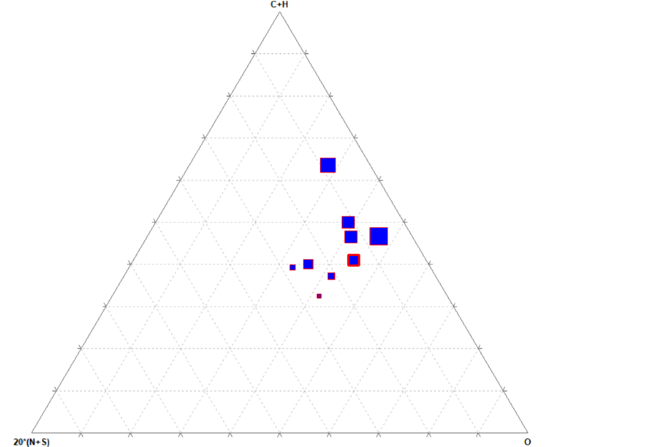

Figure 4.1, Ternary plot among C+H, N+S, O

Here it is seen that for ‘C+H’ value around 50% and comparatively lesser values of ‘N+S’ and relatively higher values of oxygen content biochar content is comparatively more.

The data set considered for this ternary plot analysis is small (only ten feedstocks) as a lot of manual work is to be performed if more feedstocks are to be incorporated, due to this reason the result might not be very accurate, but if more feedstocks are taken then the same analysis will produce more accurate results.

**4.2 Ternary plot among proximate analysis parameters to predict biochar output: (a rough model)**

10 feedstocks with varying biochar yield are taken and their volatile, ash and fixed carbon content values are taken and a ternary plot among them is drawn. In the diagram below larger boxes indicate more higher biochar yield.

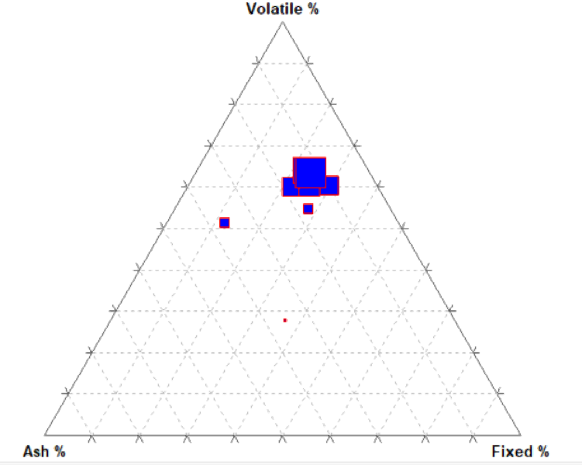

Figure 4.2, Ternary plot among ash content, volatile content and fixed carbon

Here it can be seen for a relatively lower value of ash content and higher values of volatile content, biochar output is more.

The data set considered for this ternary plot analysis is small (only ten feedstocks) as a lot of manual work is to be performed if more feedstocks are to be incorporated, due to this reason the result might not be very accurate, but if more feedstocks are taken then the same analysis will produce more accurate results.

**5. PREDICTION OF BIOCHAR USING MACHINE LEARNING TECHNIQUES**

**5.1 Introduction**

In the previous work it is predicted which parameter is significant or effective for the production of biochar yield, the next is to determine which of those parameters (temperature, residence time, volatile content, hydrogen) are more effective and to get a rough equation among the input and output parameter (biochar), previously the dataset that was considered had 76 rows but for better results 43 more feedstocks are added, ending up with 119 rows in the dataset. Table 5.1 with effective parameters and output put together for 119 feed stocks taken.

The reason for selecting only 5 parameters which are temperature, residence time, volatile content and hydrogen for analysis, is because they are significant (affecting the biochar output) as concluded by ANOVA test.

Table 5.1. Effective parameters and output biochar for feedstocks put together

|  |  |  |  |  |  |
| --- | --- | --- | --- | --- | --- |
| Final temper ature(°C) | Residence_ Time(min) | Power(W) | Volatile_Content (%) | Hydrogen (%) | Biochar (%) |
| 500 | 10 | 800 | 79.9 | 5.9 | 35.3 |
| 500 | 10 | 800 | 79.9 | 5.9 | 32 |
| 500 | 10 | 800 | 77.9 | 5.8 | 34.4 |
| 500 | 10 | 800 | 84.6 | 6 | 33.4 |
| 500 | 10 | 800 | 59.4 | 5.7 | 62.9 |
| 550 | 11.2 | 800 | 54.68 | 5.09 | 30 |
| 550 | 11.5 | 800 | 70.81 | 10.93 | 20 |
| 550 | 11.5 | 800 | 60.05 | 6.85 | 26 |
| 550 | 13 | 800 | 62.82 | 8.01 | 25 |
| 550 | 15 | 800 | 65.43 | 8.62 | 21 |
| 600 | 11 | 450 | 68.7 | 6.3 | 32.6 |
| 600 | 10.5 | 450 | 74.5 | 5.8 | 13.5 |
| 600 | 10.3 | 450 | 51.4 | 4.8 | 40.1 |
| 600 | 9.1 | 450 | 74.9 | 6.6 | 24 |
| 600 | 10.7 | 450 | 80 | 6 | 21.9 |
| 600 | 9.74 | 450 | 93.7 | 7.1 | 0.8 |
| 600 | 12.34 | 450 | 99.5 | 8.5 | 6 |
| 600 | 10.5 | 450 | 84.1 | 7.4 | 17.9 |
| 600 | 11.7 | 450 | 87 | 7.15 | 12.9 |
| 600 | 10.4 | 450 | 75.45 | 6.65 | 22.7 |
| 600 | 11.8 | 450 | 87.2 | 7.55 | 15.9 |
| 600 | 10.2 | 450 | 89.75 | 7.25 | 13.1 |
| 600 | 13 | 450 | 81.2 | 6.7 | 19.2 |
| 600 | 12 | 450 | 84.1 | 6.45 | 16.5 |
| 600 | 11.6 | 450 | 72.55 | 5.95 | 24.2 |
| 600 | 11 | 450 | 84.3 | 6.85 | 17.9 |
| 600 | 12 | 450 | 86.85 | 6.55 | 15.4 |
| 800 | 8.5 | 420 | 60.2 | 6.4 | 38.3 |
| 800 | 7 | 560 | 60.2 | 6.4 | 35.1 |
| 800 | 6.5 | 420 | 60.2 | 6.4 | 36.7 |
| 800 | 6.5 | 560 | 60.2 | 6.4 | 34.8 |
| 800 | 11 | 420 | 27.9 | 5.6 | 61.9 |
| 800 | 8.9 | 560 | 27.9 | 5.6 | 65.3 |
| 800 | 8.2 | 420 | 27.9 | 5.6 | 69.6 |
| 800 | 11 | 560 | 27.9 | 5.6 | 65.8 |
| 800 | 12.2 | 420 | 35.975 | 5.8 | 58.2 |
| 800 | 11 | 420 | 35.975 | 5.8 | 60.9 |
| 800 | 12 | 560 | 35.975 | 5.8 | 61.2 |
| 800 | 7.2 | 560 | 35.975 | 5.8 | 58.9 |
| 800 | 12.2 | 420 | 44.05 | 6 | 55.1 |
| 800 | 10.5 | 420 | 44.05 | 6 | 56.6 |
| 800 | 8.1 | 560 | 44.05 | 6 | 52.6 |
| 800 | 8.1 | 560 | 44.05 | 6 | 50 |
| 800 | 10.5 | 420 | 52.125 | 6.2 | 46.7 |
| 800 | 8.2 | 420 | 52.125 | 6.2 | 48.2 |
| 800 | 7.5 | 560 | 52.125 | 6.2 | 46.4 |
| 800 | 6.5 | 560 | 52.125 | 6.2 | 45.7 |
| 1000 | 6 | 1000 | 62.3 | 8 | 10.7 |
| 500 | 20 | 130 | 77 | 6.4 | 30.2 |
| 800 | 20 | 270 | 77 | 6.4 | 25.53 |
| 1000 | 20 | 420 | 77 | 6.4 | 22.7 |
| 800 | 15 | 1200 | 38.69 | 2.84 | 70 |
| 800 | 15 | 1200 | 50.47 | 4.31 | 55 |
| 800 | 15 | 1200 | 61.47 | 4.84 | 49 |
| 800 | 15 | 1200 | 70.78 | 5.99 | 39 |
| 200 | 25 | 600 | 74.8 | 6.3 | 48.39 |
| 200 | 13.3 | 900 | 74.8 | 6.3 | 45.16 |
| 200 | 10 | 1200 | 74.8 | 6.3 | 43.23 |
| 700 | 22 | 450 | 94.8 | 11.3 | 4.7 |
| 700 | 34 | 600 | 94.8 | 11.3 | 8 |
| 700 | 20 | 600 | 94.8 | 11.3 | 5.4 |
| 700 | 12 | 600 | 94.8 | 11.3 | 9.8 |
| 700 | 9.5 | 600 | 94.8 | 11.3 | 9.2 |
| 700 | 10 | 800 | 94.8 | 11.3 | 7.1 |
| 700 | 11 | 600 | 98.1 | 5.1 | 44.4 |
| 290 | 25 | 450 | 75 | 6.5 | 80 |
| 560 | 25 | 450 | 75 | 6.5 | 48 |
| 455 | 25 | 450 | 75 | 6.5 | 50 |
| 305 | 25 | 450 | 75 | 6.5 | 65 |
| 280 | 25 | 450 | 75 | 6.5 | 80 |
| 300 | 25 | 450 | 75 | 6.5 | 68 |
| 450 | 25 | 450 | 75 | 6.5 | 51 |
| 550 | 25 | 450 | 75 | 6.5 | 49 |
| 670 | 10 | 700 | 76.13 | 6.9 | 23 |
| 1050 | 10 | 700 | 58.39 | 5.18 | 29 |
| 300 | 50 | 2000 | 58.39 | 5.18 | 56.69 |
| 400 | 50 | 2000 | 58.39 | 5.18 | 44.83 |
| 500 | 50 | 2000 | 58.39 | 5.18 | 37.16 |
| 600 | 50 | 2000 | 58.39 | 5.18 | 34.59 |
| 300 | 50 | 2000 | 58.39 | 5.18 | 60.16 |
| 400 | 50 | 2000 | 58.39 | 5.18 | 38.06 |
| 500 | 50 | 2000 | 58.39 | 5.18 | 33.98 |
| 600 | 50 | 2000 | 58.39 | 5.18 | 31.2 |
| 500 | 50 | 2000 | 58.39 | 5.18 | 36.6 |
| 500 | 50 | 2000 | 58.39 | 5.18 | 37.2 |
| 500 | 50 | 2000 | 58.39 | 5.18 | 34.89 |
| 500 | 50 | 2000 | 58.39 | 5.18 | 31.26 |
| 300 | 50 | 2000 | 72.51 | 6.22 | 60.88 |
| 400 | 50 | 2000 | 72.51 | 6.22 | 27.24 |
| 500 | 50 | 2000 | 72.51 | 6.22 | 30.59 |
| 600 | 50 | 2000 | 72.51 | 6.22 | 24.84 |
| 300 | 50 | 2000 | 72.51 | 6.22 | 57.1 |
| 400 | 50 | 2000 | 72.51 | 6.22 | 38.31 |
| 500 | 50 | 2000 | 72.51 | 6.22 | 35.27 |
| 600 | 50 | 2000 | 72.51 | 6.22 | 19.91 |
| 500 | 50 | 2000 | 72.51 | 6.22 | 35.75 |
| 500 | 50 | 2000 | 72.51 | 6.22 | 33.31 |
| 500 | 50 | 2000 | 72.51 | 6.22 | 19.88 |
| 500 | 50 | 2000 | 72.51 | 6.22 | 20.2 |
| 690 | 40 | 1000 | 78.97 | 7.5 | 23 |
| 645 | 40 | 1000 | 60.33 | 6.73 | 46 |
| 680 | 40 | 1000 | 73.378 | 7.269 | 32 |
| 750 | 40 | 1000 | 69.65 | 7.115 | 33 |
| 490 | 40 | 1000 | 65.922 | 6.961 | 41 |
| 580 | 40 | 1000 | 78.97 | 7.5 | 25 |
| 700 | 40 | 1000 | 60.33 | 6.73 | 50 |
| 620 | 40 | 1000 | 73.378 | 7.269 | 30 |
| 750 | 40 | 1000 | 69.65 | 7.115 | 36 |
| 620 | 40 | 1000 | 65.922 | 6.961 | 42 |
| 800 | 25 | 1000 | 71.63 | 7 | 31.2 |
| 800 | 25 | 1000 | 79.76 | 6.63 | 17.1 |
| 800 | 25 | 1000 | 77.321 | 6.741 | 22.3 |
| 800 | 25 | 1000 | 75.695 | 6.815 | 29.9 |
| 800 | 25 | 1000 | 74.069 | 6.889 | 31.1 |
| 800 | 25 | 1000 | 71.63 | 7 | 23.9 |
| 800 | 25 | 1000 | 79.76 | 6.63 | 11.5 |
| 800 | 25 | 1000 | 77.321 | 6.741 | 20.7 |
| 800 | 25 | 1000 | 75.695 | 6.815 | 24.1 |
| 800 | 25 | 1000 | 74.069 | 6.889 | 23.7 |

**5.2 Linear regression analysis:**

For performing the linear regression analysis Jupyter notebook (with python) was used and the procedure goes as follows:

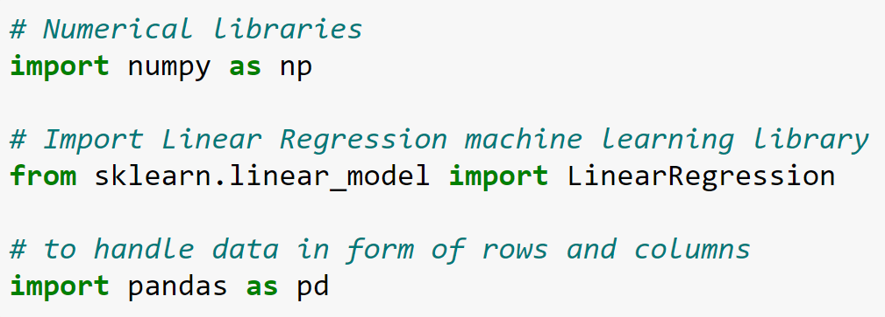

Figure 5.1

1. To feed data (Table 5.1) to jupyter notebook:

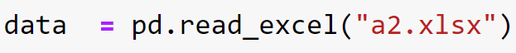

Figure 5.2

1. To get rough corelation among the variables using the command



Figure 5.3

1. To train and test data 70% of the data is used for training and the rest 30% is used for testing and the code for this is as follows:

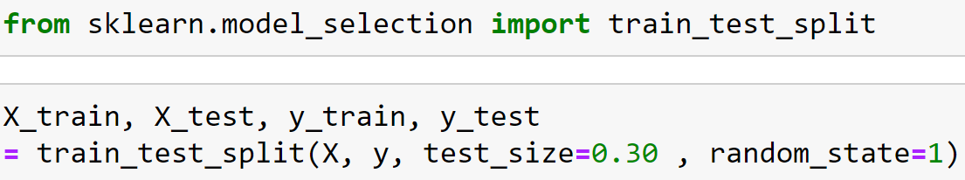

Figure 5.4

1. Then regression is done (linear regression) using the code:

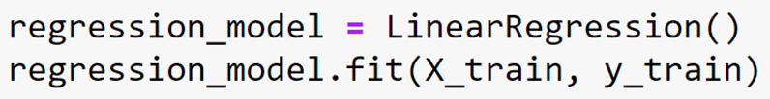

Figure 5.5

Once code for regression is done coefficients of the parameters and the intercept of the equation can be obtained with the following codes:

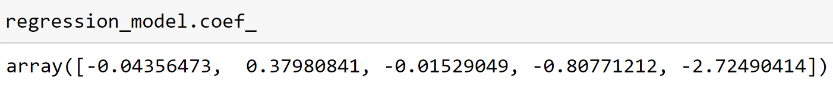

Figure 5.6

Coefficients being ([-0.04356473, 0.37980841, -0.01529049, -0.80771212, -2.72490414]) of

Final temperature, Residence Time(min), Power(Watts), Volatile Content(%) and Hydrogen% respectively and 140.47 being the intercept and can also be seen from this table below using the code



Figure 5.7

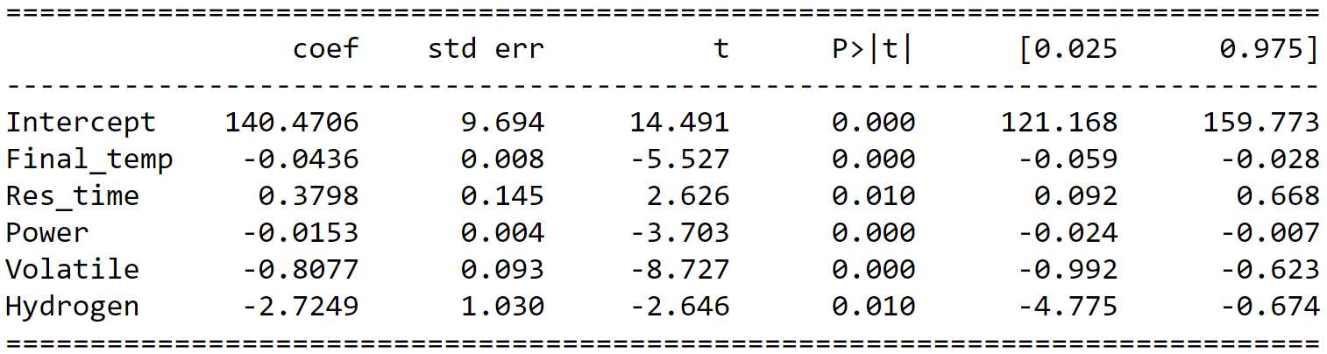

Figure 5.8

Hence from the above results a rough formula for biochar can be deduced:

## Biochar = 140.47 + (-0.0436 * Final_temp) + ( 0.3798 * Res_time ) + ( -0.0153 * Power ) + ( -0.8077 * Volatile ) + ( -2.7249 * Hydrogen )

1. To get the accuracy of the model:

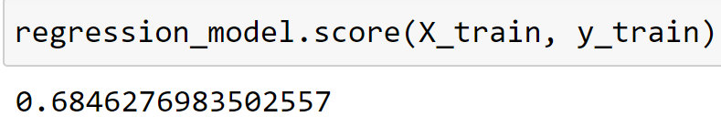 so accuracy is 68.46%

Figure 5.9

Hence with this model we can predict the biochar output with an accuracy of 68.5% which is not desirable. To get a better model we can perform ANN regression (artificial neural network), decision tree regression, Random forest regression and see which model yields best results.

To get a better model what is to be done next is to perform all the mentioned regressions simultaneously and choose the one which gives the best accuracy.

**5.3 Multiple regressors (ANN, decision tree and Random forest regressions):**

The below mentioned code is to import the libraries, to train and to test the model simultaneously for all the three regressions mentioned above.

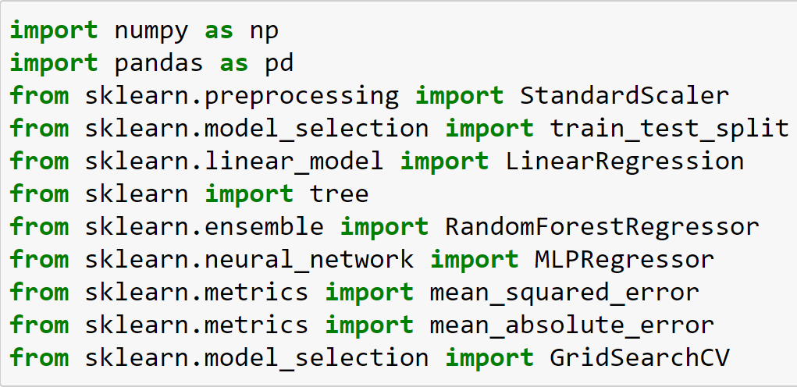

Figure 5.10

Here we have to import (call) important libraries such as pandas, numpy and other important library relating to sklearn as shown above.

In the next step we have to scale the data (both training and testing data) for ANN using standardscaler, which helps in giving good results and also computations become easier.

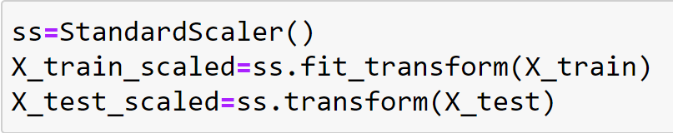

Figure 5.11

Scaled data is used only for ANN model, as this model need scaled data to work effectively if unscaled data is fed huge errors may be encountered. Rest of the models which are decision tree regressor and random forest regressor both can take normal or raw data.

Then next step is to assign the regressors to variables (annr, rfr, dtr, regression_model) and also to assign null arrays to training and testing which can be filled with the results when suitable code is given.

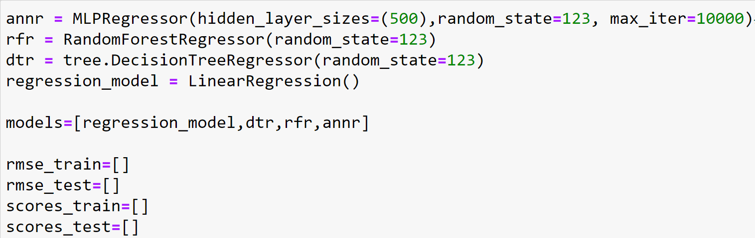

Figure 5.12

After scaling data, the data which is scaled is fed to ANN model and data which is not scaled is fed to the rest of the model, for this very purpose if else loop is used.

Simultaneously algorithm is given which would append (add) result to the null arrays assigned for training and testing.

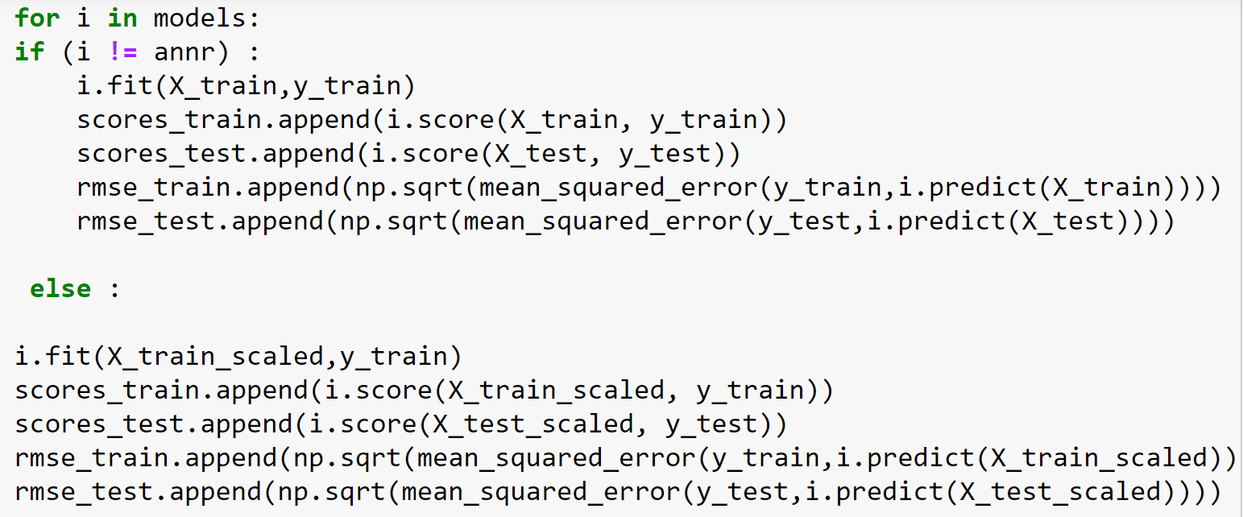

Figure 5.13

Now to get the data in tabular format (data frame) the following command is used.

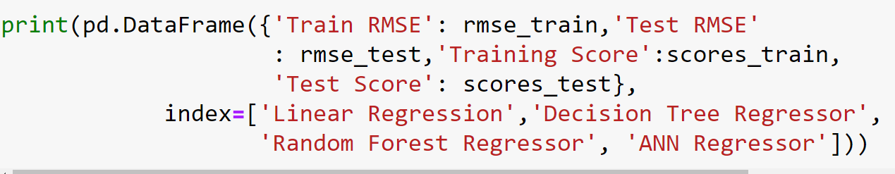

Figure 5.14

By running the code the final output is shown below.

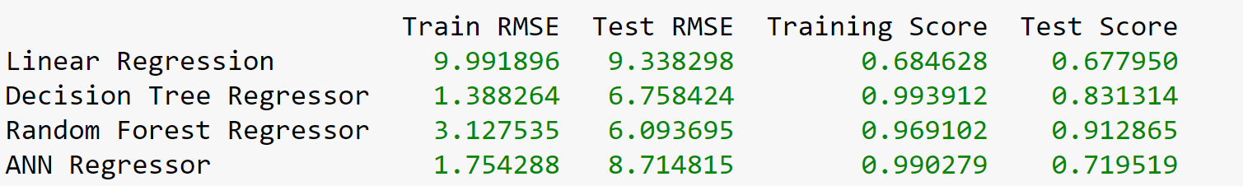

Figure 5.15

From the above 4 models, Random forest model gave the best test score, so Random forest regressor can be incorporated.

To predict biochar output for any given set of final temperature, residence time, power, Volatile content, hydrogen content the following code can be used.

rfr.predict([[800,8.9,560,27.900,5.600]])

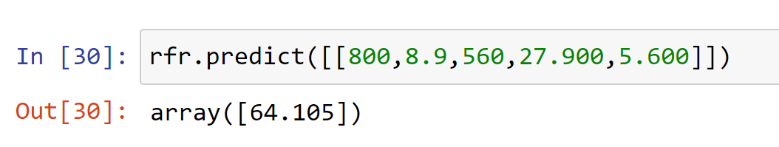

Figure 5.16

From the figure 5.16 it can be seen that for a final temperature of 800°C, 8.9 minute residence time, 560 W power, 27.9% volatile content and 5.6% hydrogen content the biochar output would be 64.1%.

**6. GRAPHICAL INFERENCE**

To get a much better understanding of model, predicted data can be compared with actual data and check whether the comparison is good enough. For that very purpose 15 feedstock data were taken randomly and the code was assigned to each feedstock data in the below mentioned manner.

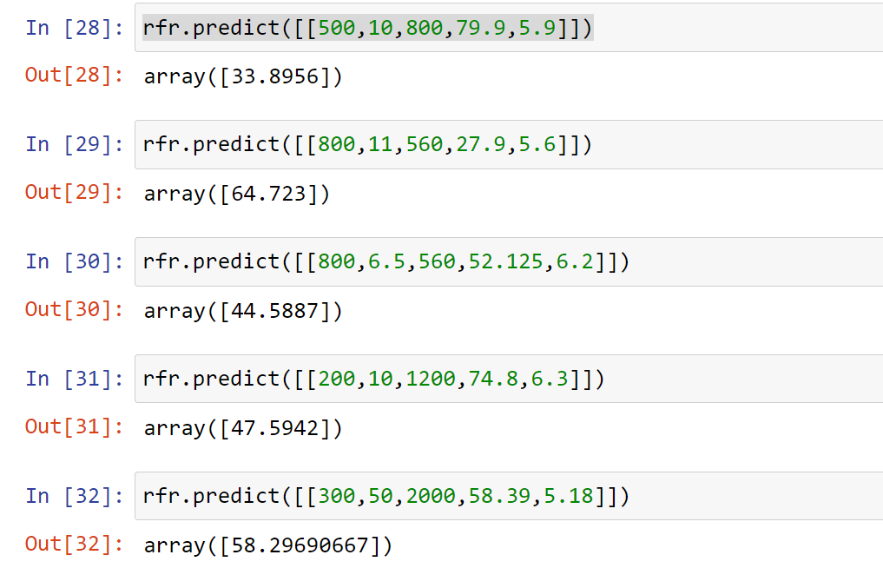

Figure 6.1

The code was run for all 15 feedstock data as shown in the above figure, then actual biochar and predicted biochar are concatenated as shown below.

Table 6.1. Biochar (actual) and biochar (predicted) values

|  |  |  |  |  |  |  |  |
| --- | --- | --- | --- | --- | --- | --- | --- |
| S.No | Final temperature | Residence_Time  (min) | Power (Watts) | Volatile_ Content(%) | Hydrogen% | Biochar% (actual) | Biochar% (predicted) |
| 1 | 500 | 10 | 800 | 79.9 | 5.9 | 35.3 | 33.8 |
| 2 | 500 | 10 | 800 | 77.9 | 5.8 | 34.4 | 35.1 |
| 3 | 800 | 11 | 560 | 27.9 | 5.6 | 65.8 | 64.8 |
| 4 | 800 | 10.5 | 420 | 52.125 | 6.2 | 46.7 | 44.6 |
| 5 | 800 | 8.2 | 420 | 52.125 | 6.2 | 48.2 | 49.4 |
| 6 | 800 | 7.5 | 560 | 52.125 | 6.2 | 46.4 | 46 |
| 7 | 800 | 6.5 | 560 | 52.125 | 6.2 | 45.7 | 44.58 |
| 8 | 200 | 25 | 600 | 74.8 | 6.3 | 48.39 | 49.8 |
| 9 | 200 | 13.3 | 900 | 74.8 | 6.3 | 45.16 | 43.9 |
| 10 | 200 | 10 | 1200 | 74.8 | 6.3 | 43.23 | 47.59 |
| 11 | 300 | 50 | 2000 | 58.39 | 5.18 | 56.69 | 55.6 |
| 12 | 400 | 50 | 2000 | 58.39 | 5.18 | 44.83 | 42.8 |
| 13 | 500 | 50 | 2000 | 58.39 | 5.18 | 37.16 | 35.33 |
| 14 | 600 | 50 | 2000 | 58.39 | 5.18 | 34.59 | 35.88 |
| 15 | 300 | 50 | 2000 | 58.39 | 5.18 | 60.16 | 58.29 |

For the purpose of comparison graph is drawn for biochar predicted vs biochar actual using Microsoft excel using scatter command.

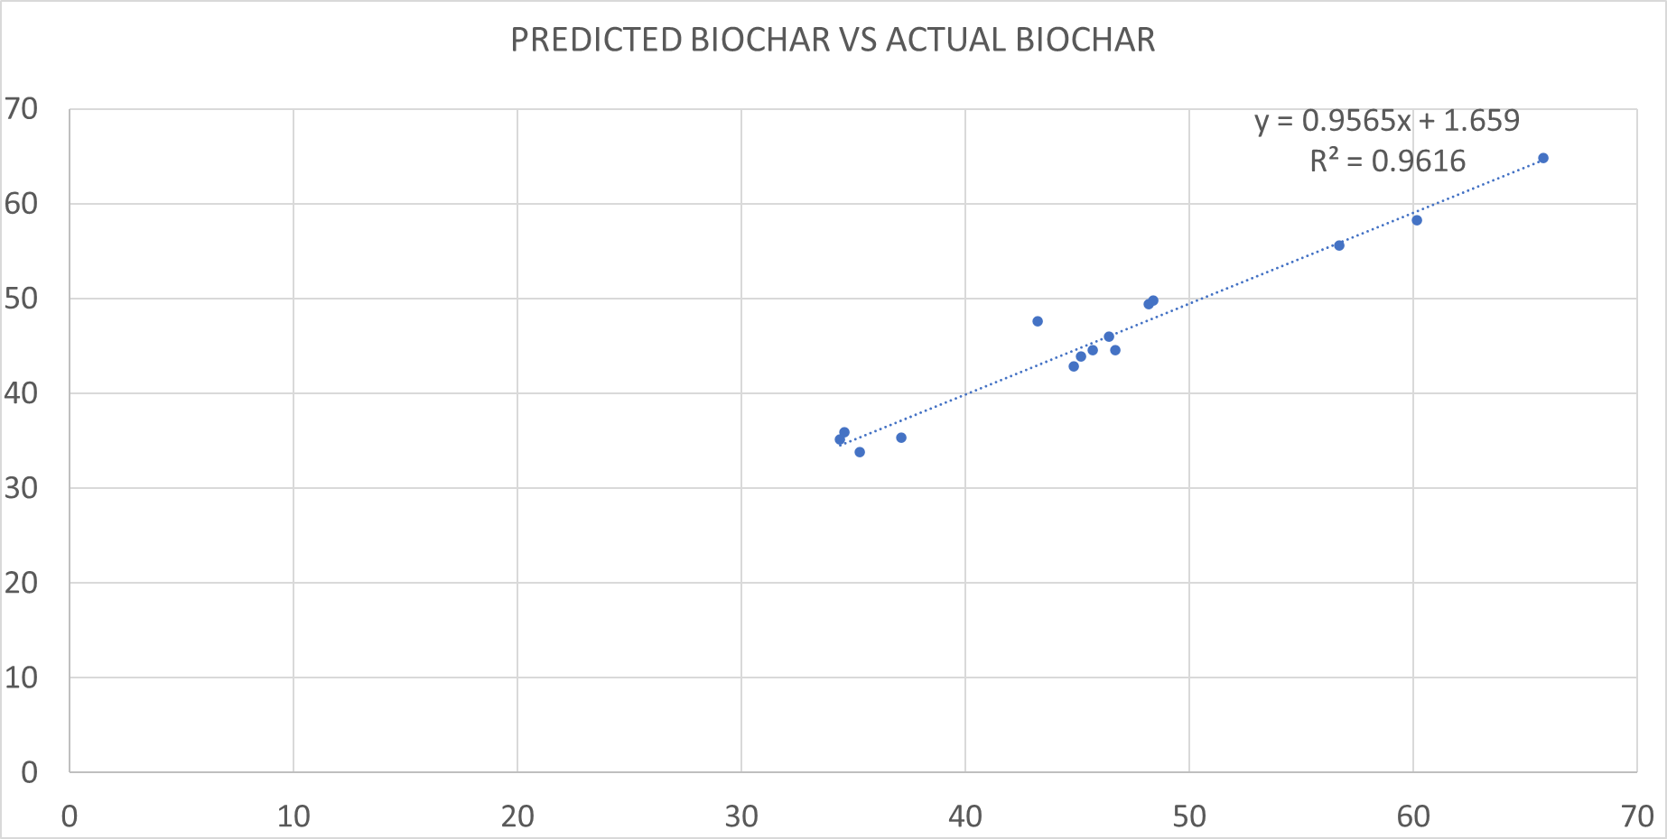

Figure 6.2

It can be seen that the graph is well fit as slope is nearly equal to 1 (slope is 0.9565 as seen from the figure 5.18) and also the intercept being very less and R square value = 0.9616 is also very good.

The equation of the curve being:

**7. CONCLUSION**

From table 3.10 it can be said that temperature, residence time, power, volatile content, hydrogen percentage are the significant parameters (parameters that effect the biochar output) as their P values are less than 0.05.

From ternary plots it can be seen that:

For ‘C+H’ value around 50% and comparatively lesser values of ‘N+S’ and relatively higher values of oxygen content biochar content is comparatively more.

For a relatively lower value of ash content and higher values of volatile content, biochar output is more.

From results from regression models it can be seen that:

Linear regression model which was the first trail model cannot be used as the accuracy acquired is too low (0.68) to consider.

Other models are to be incorporated for better results.

Of all the used regression models, random forest regressor gave the best test score=91% (accuracy), so this model works for the data used.

From graphical inference also it can be seen that graph’s R-square value=0.96, also line’s slope is nearly equal to 1 and also the intercept is very less which means the model is accurate.

**8. FUTURE SCOPE AND RECOMMENDATIONS**

The work which has been done mainly focuses on the significant parameters and the estimation of quantity of the biochar produced from a given feedstock, but estimation of quality of the biochar produced is also equally important, analysis can also be done to estimate the quality of the biochar produced from a given feedstock but for that purpose much experimental work is required such as assessing the evaluation of its effect on crops, analysing it’s porosity using different lab techniques etc. Machine learning techniques can only be applied to do quantitative analysis so these techniques can’t be used to estimate the quality of biochar obtained.

**REFERENCES**

1. Microwave assisted fast pyrolysis of corn cob, corn stover, saw dust and rice straw: Experimental investigation on bio-oil yield and high heating values C. Ravikumar a, ⁎, P. Senthil Kumar b, ⁎, S.K. Subhashni b , P.V. Tejaswini b , V. Varshini b
2. Properties of chars from the gasification and pyrolysis of rice waste streams towards their valorisation as adsorbent materials
3. The valorization of food waste via pyrolysis

Soosan Kim a, 1, Younghyun Lee a, 1, Kun-Yi Andrew Lin b, Eunmi Hong c, ***,

Eilhann E. Kwon d, **, Jechan Lee

1. Abbasi, S., 2018. The myth and the reality of energy recovery from municipal solid

waste. Energy Sustain. Soc. 8 (1), 36.

1. Ahmad, M., Rajapaksha, A.U., Lim, J.E., Zhang, M., Bolan, N., Mohan, D.,

Vithanage, M., Lee, S.S., Ok, Y.S., 2014. Biochar as a sorbent for contaminant

management in soil and water: a review. Chemosphere 99, 19e33.

1. Ahmad, N., Baharudin, N.N.H., Talib, N., 2019. Slow pyrolysis temperature and

duration effects on fuel properties of food rice waste bio-char. Key Eng. Mater.

797, 319e326

1. Duman, G., Yanik, J., 2017. Two-step steam pyrolysis of biomass for hydrogen production.

Int. J. Hydrogen Energy 42 (27), 17000e17008.

1. Elkhalifa, S., Al-Ansari, T., Mackey, H.R., McKay, G., 2019. Food waste to biochars

through pyrolysis: a review. Resour. Conserv. Recycl. 144, 310e320.

1. Fadhil, A.B., Ahmed, A.I., Salih, H.A., 2017. Production of liquid fuels and activated

carbons from fish waste. Fuel 187, 435e445.

1. Foong, S.Y., Liew, R.K., Yang, Y., Cheng, Y.W., Yek, P.N.Y., Mahari, W.A.W., Lee, X.Y.,

Han, C.S., Vo, D.-V.N., Van Le, Q., Aghbashlo, M., Tabatabaei, M., Sonne, C.,

1. Peng,W., Lam, S.S., 2020. Valorization of biomass waste to engineered activated

biochar by microwave pyrolysis: progress, challenges, and future directions.

Chem. Eng. J. 389, 124401.

1. Higman, C., van der Burgt, M., 2003. Gasification. Gulf Professional Publishing.
2. Hmid, A., Mondelli, D., Fiore, S., Fanizzi, F.P., Al Chami, Z., Dumontet, S., 2014. Production

and characterization of biochar from three-phase olive mill waste

through slow pyrolysis. Biomass Bioenergy 71, 330e339.

1. Huang, J., Liu, C., Tong, H., Li, W., Wu, D., 2012. Theoretical studies on pyrolysis

mechanism of xylopyranose. Comput. Theor. Chem. 1001, 44e50.

1. Jahirul, M.I., Rasul, M.G., Chowdhury, A.A., Ashwath, N., 2012. Biofuels production

through biomass pyrolysisda technological review. Energies 5 (12),

4952e5001.

1. Jia, X., Xi, B., Li, M., Xia, T., Hao, Y., Liu, D., Hou, J., 2017. Evaluation of biogasification

and energy consumption from food waste using short-term hydrothermal

pretreatment coupled with different anaerobic digestion processes. J. Clean.

1. Estimating profitability of two biochar production scenarios:

slow pyrolysis vs fast pyrolysis.

1. Ringer M, Putsche V and Scahill J, Large-scale pyrolysis oil production:

a technology assessment and economic analysis. NREL/TP-510-37779,

Natl Renew Energy Lab, Golden, Colorado (2006).

1. Laird DA, Brown RC, Amonette JE and Lehmann J, Review of the

Pyrolysis Platform for Producing Bio-oil and Biochar: Technology,

1. Logistics and Potential Impacts on Greenhouse Gas Emissions, Water

Quality, Soil Quality and Agricultural Productivity. Biofuels, Bioprod